Navigating the AI Adoption in the Workforce: Case of Indonesia

Introduction
The exponential growth in capabilities shown by Artificial Intelligence (AI) in recent years has spurred an ongoing debate over whether human labor will be replaced by AI. Acemoglu et al. (2023) have argued that artificial intelligence will likely persist, but simply displacing labor would not yield good results for the labor market, and there is no inevitable future of AI development in which we cannot advocate. ​The AI's impact on labor displacement would likely differ across industries. This calls for an analysis which industries would benefit from fully automated jobs or whether a human-centric development of artificial intelligence would be better off for all.
Anthropic recently released a report titled “Anthropic Economic Index Report: Economic Primitives.” (Appel et al, 2026). The report brings a new light to the research on AI and how it shapes current and future labor market. Understanding the risk incurred with the increasing speed of AI adoption across industry and jobs are essential for the business and countries to strategize. Labor across the world will need to adapt and get the optimal benefits while minimizing the potential risks of negative outcome.
This paper will focus on Indonesia and the its adoption rate of artificial intelligence with usage of Claude AI as a proxy. AI adoption in Indonesia will be examined through its usage across different industries and jobs. The data provided will help us understand the current state of AI adoption in Indonesia. This data will then be compared into how labor on average adopt AI in the world.

Literature Review
Acemoglu and Restrepo (2019a) define AI-based productivity gains can come from automation, task complementarity, deepening of automation and new tasks created to accommodate AI use in workplace. Automation is the model of AI taking over and reduce the time needed to perform task. Task complementarity is the use of AI through the increase of productivity of labor in performing tasks that are not fully automated. Details and about the deepening of automation and new tasks created to accommodate AI use in workplace is out of the scope of this paper.
Acemoglu (2024) estimates that the impact of AI in the production function happens through the cost savings effects either by the automation or task complementarities. These increase in the productivity would only affect the portion of the GDP with tasks that has exposure to the AI adoption in its production.
Impact of Artificial Intelligence in the form of Large Language Model and Generative Pre-trained Transformer (GPT) on the labor market was examined in the paper of Eloundou et. al (2023). The paper use data on activities and tasks performed by occupation in the use in the O*NET database which contain information on 1,016 occupations and its respective Detailed Work Activities (DWA) and task (Eloundou et.al, 2023). Task is defined as an occupation-specific unit of work that may be associated with zero, one, or multiple DWAs.
Eloundou et al. then uses GPT-4 to classify all 19,265 tasks and 2,087 DWA to produce a task-level exposure estimate. It used both human and GPT-4 generated annotations to create estimates of exposure, measured as β, which measure whether it is theoretically possible for an LLM to make a task at least twice as fast.
Paper of Anthropic Economic Index Report uses the tasks associated with 800 occupations from the O*NET database, and also the usage data from Anthropic Economic Index to map how AI has been used across industries and countries (Appel et al, 2026).
AUI
Difference level of observed exposure across countries need to be studied to understand how a country have exposure of AI compared to other countries and global median. Balassa (1965) find that Revealed Comparative Advantage (RCA) can helps explain the difference of production function across countries through the export as a result of the production. RCA works by evaluating the relative level of an export to the total export of a country and also to the total global export.
We argue that RCA can be used to do comparative analysis of AI exposure in the tasks level and occupation level. This will help understand how AI is currently being used in the workforce in each country and also across countries in the global level.
Estimating the tasks that are uses
We use Revea
Dataset is

Methodologies

Result
Task penetration is defined as how much AI usage is done on the job. Preliminary result was done by calculating the mean task penetration across job family defined by Anthropic. The diagram shows that in Indonesia, Computer and mathematical still dominates as the job family with highest AI usage.
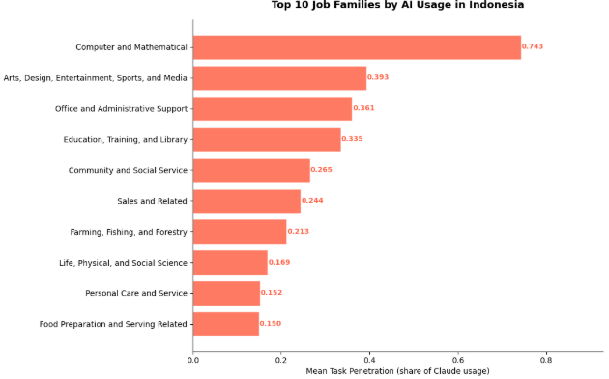
Figure SEQ Figure \* ARABIC 1 Top 10 Job Families by AI Usage in Indonesia

Conclusion

References

Acemoglu, Daron. 2024. "The Simple Macroeconomics of AI." NBER Working Paper 32487, National Bureau of Economic Research, Cambridge, MA.
Acemoglu, Daron, and Pascual Restrepo, “Artificial Intelligence, Automation, and Work,” The Economics of Artifical Intelligence: An Agenda, 2019, pp. 197–236. Edited by Ajay Agrawal, Joshua Gans and Avi Goldfarb. Chicago, USA: University of Chicago Press.
Acemoglu, Daron, David Autor, and Simon Johnson. 2023. "Can We Have Pro-Worker AI? Choosing a Path of Machines in Service of Minds." Policy Memo, MIT Shaping the Future of Work Initiative, September 19, 2023.
Appel, Ruth, Peter McCrory, Alex Tamkin, Michael Stern, Miles McCain, and Tyler Neylon. 2025. "Anthropic Economic Index Report: Uneven Geographic and Enterprise AI Adoption." September 15, 2025. https://www.anthropic.com/research/anthropic-economic-index-september-2025-report.
Eloundou, Tyna, Sam Manning, Pamela Mishkin, and Daniel Rock. “GPTs Are GPTs: An Early Look at the Labor Market Impact Potential of Large Language Models.” arXiv:2303.10130. Preprint, arXiv, August 21, 2023. https://doi.org/10.48550/arXiv.2303.10130.
Massenkoff, M., & McCrory, P. (2026, March 5). Labor market impacts of AI: A new measure and early evidence. Anthropic. https://www.anthropic.com/research/labor-market-impacts

